**Research Module**

**1. Introduction**

**1.1 Overview**

The Research Module is basically for faculties.

**1.2 Purpose:-**

The purpose of this document is to provide stakeholders, developers, and users with a comprehensiveunderstanding of the Attendance Module, its objectives, and its implementation.

**2. System Overview**

**2.1 Faculty Perspective:-**

* Faculty members can view the list of lectures.
* They can mark attendance for each lecture.
* Specific scenarios are considered for marking attendance:-
* Continuous lectures can be marked with a single attendance entry.
* Attendance can be marked within 9 hours after the scheduled lecture time.

**2.2 Student Perspective:-**

* Students can view the list of lectures.
* They can view the attendance status for each lecture.

**3.Database:-**

In the PostgreSQL database:

* There is a daily_attendance_slot table in the sap_master database where all attendance data is stored, which comes from SAP.
* From the daily_attendance_slot table, data is transferred to the attendance database.
* The attendance database contains two main tables:
* **daily_attendance_slot**: This table holds data received from the sap_master database.
* **student_attendance**: This table stores the daily attendance data marked by faculty members on weekly basis.
* **student_attendance_all :-** This table will store the complete attendance data marked by faculty members.

**4. Screenshots :-**

**4.1. Faculty Side:-**

**4.1.1. Faculty's lecture page:-**

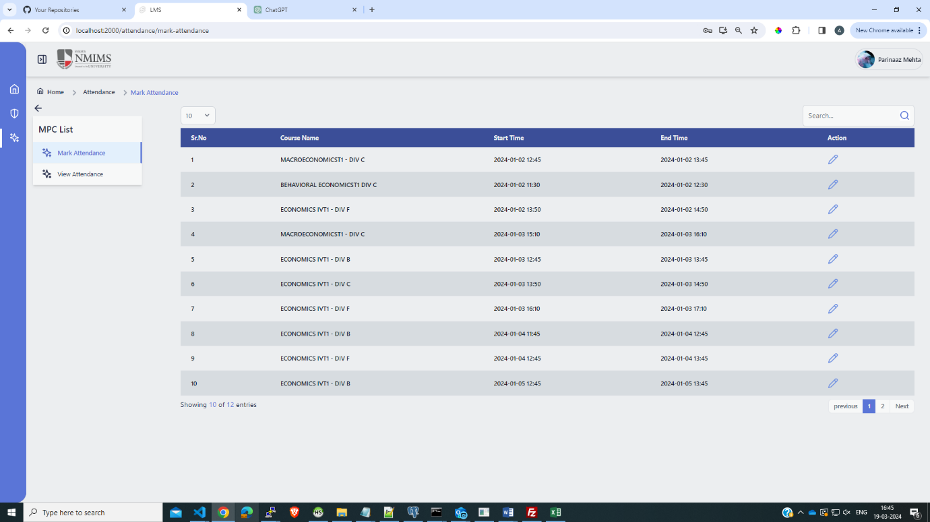

This Page displays the total lecture list assigned to the faculty member for the day

**4.1.2. Marking attendance for a selected lecture:-**

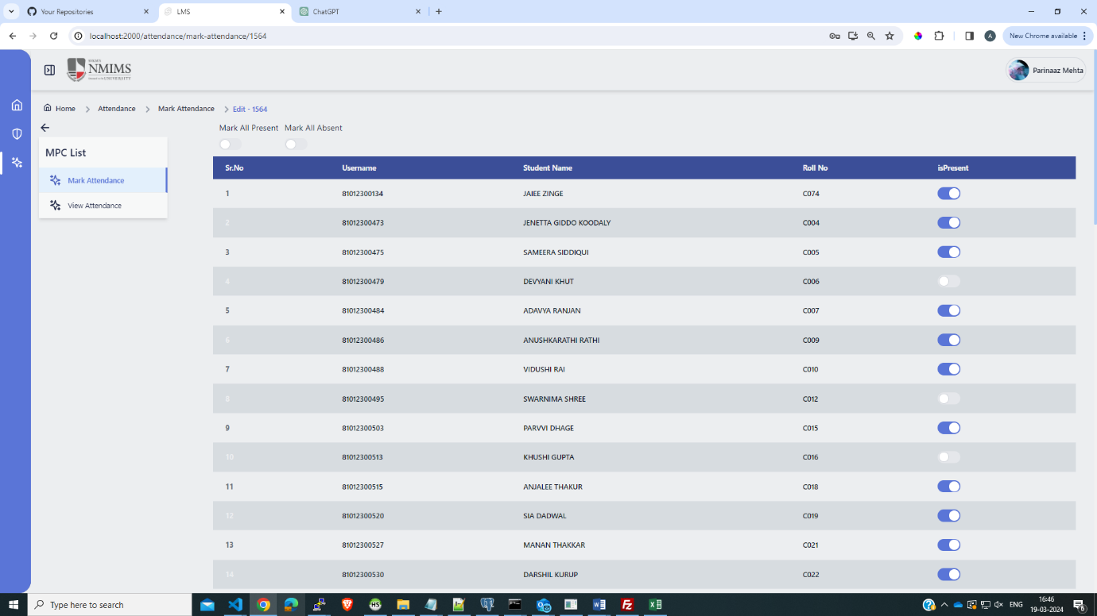

In this page faculty members can mark attendance for the selected lecture

**4.1.3. Lecture list of marked attendance:-**

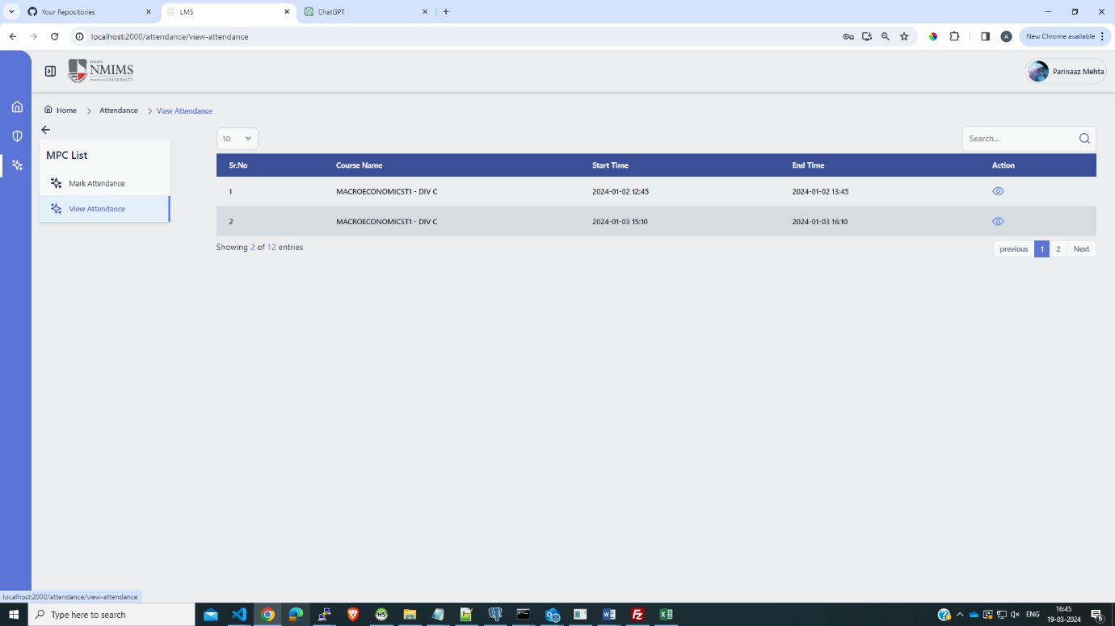

This page presents the list of lectures for which attendance has been marked by the faculty member

**4.1.4. Detailed view of marked student attendance for a selected lecture:-**

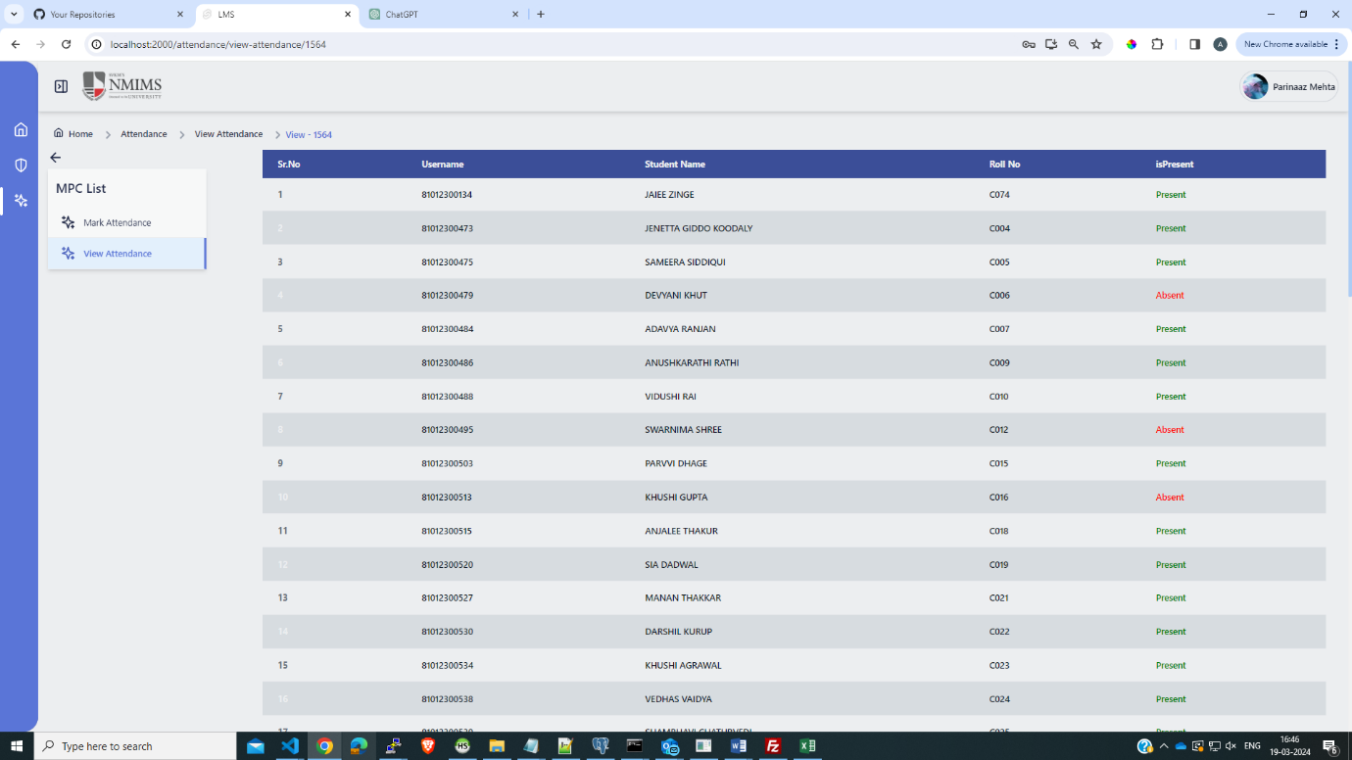

This Page provides a detailed view of the attendance status of students marked by the faculty member for a selected lecture

**4.2. Student Side:-**

**4.2.1. Monthly Summary Report:-**

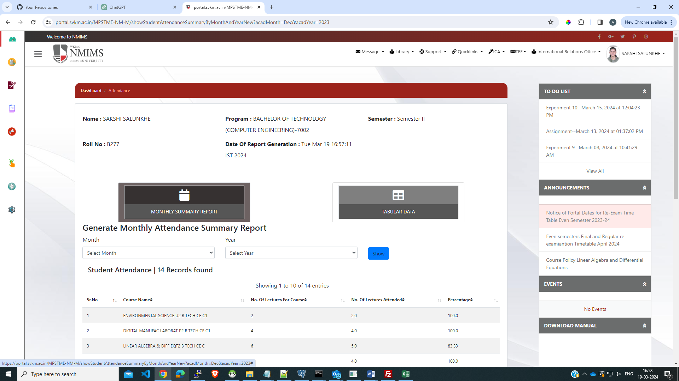

We will create similar page like above to displays the monthly summary status report of lectures attended by the student. It provides an overview of the student's attendance record for the specified month

**4.2.2.Overall Attendance Report:-**

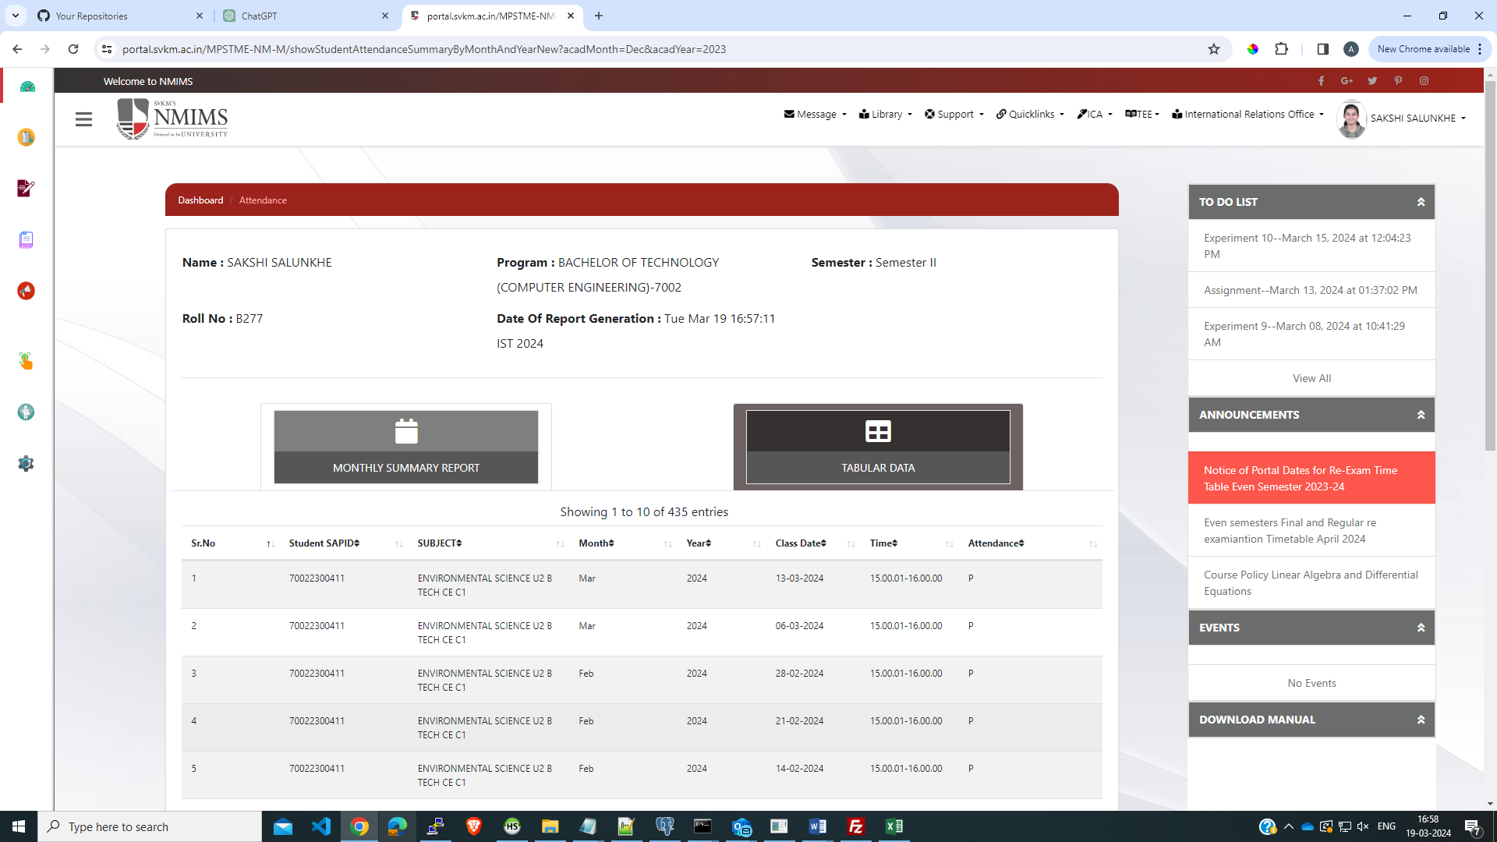

This screenshot displays the status of all lectures that the student has attended. It provides a comprehensive overview of the student's attendance history.

**5.Attendance Data To SAP:-**

The process of sending daily attendance data, including the present and absent lists of students, to the SAP team has been streamlined through WSDL integration. This ensures seamless communication and efficient transmission of information between our system and SAP.

**6. Conclusion:-**

The document outlines the functionalities of the Attendance Module, highlighting its significance in streamlining lecture management and attendance tracking within educational settings. By providing faculty members with tools to efficiently manage lectures and mark attendance, and enabling students to access lecture schedules and attendance status, the module greatly enhances operational efficiency within schools